Detail plan of the Clean 9 Detox
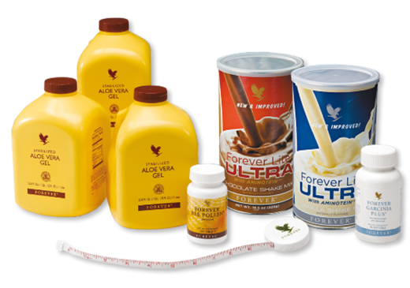
The purpose of the Clean 9 is to get rid of the harmful chemical substances inside your body and build up freshly dietary habits and lifestyle to control weight. The extra supplements will greatly enhance the detox process. This easy-to follow 9 day nutritional cleansing program provides you with all the necessary tools to help you cleanse your system and take control of your health. Our experience shows that you are more likely to stick to a program and achieve your goals if you write down your daily meals and chart your progress.
During the first 2 days, your body is forced to draw upon the stores of fat in your body for energy, resulting in weight loss and inch loss. Days 3-9 are similar to days 1+2 but with the addition of a 600-calorie meal per day – which is actually quite a lot for one meal.
The plan also contains 5 supplements that would help enhance your detox process:
1.) Garcinia Plus - Forever Garcinia Plus® is a revolutionary dietary supplement, containing ingredients that may aid in weight loss. The primary ingredient is a natural substance derived from the fruit of a Southern Asian tree, the Garcinia Cambogia, also known as the Malabar Tamarind. Specialists in plant compounds became aware of the remarkable qualities of this substance in the late 1960s, when they learned that it can temporarily inhibit the body’s production of fats from carbohydrates. It consists of a natural appetite suppressant, that would help reduce snacking desires.
2.) Bee Pollen - Pollen is the fertilizing dust of flowers. Bees gather and bring it back to their hives for food. Without pollen, plants, trees and flowers could not exist; even we depend on it. Forever Bee Pollen® is gathered in specially designed stainless steel collectors and ensures the freshest and most potent natural food. Forever Bee Pollen® is all-natural and contains no preservatives, artificial flavors, or colors. Bee Pollen is readily digestible and easily absorbed by the human body. Research by scientistssuggest that Bee Pollen provides energy and may enhance stamina.
3.) Field of Greens – This ingredient provides extra fibre and helps prevent constipation.
4.) Forever Active Probiotics - Designed to promote a healthy digestive system, Forever Active Probiotic® is a small, easy-to-swallow beadlet that helps to overcome imbalances created by our food and lifestyle choices, which can inadvertently lead to a reduction in the amount of naturally occurring
probiotics. Forever Active Probiotic® works primarily in the intestines where it assists with the process of food digestion, helping to release nutrients for absorption, and contributes positively to normal human growth and development by helping to maintain a balanced and healthy system.
5.) Forever Arctic Sea - DHA Omega-3 is naturally found throughout the body and is most abundant in the brain, eyes and heart. Just as calcium is essential for building strong bones, DHA ensures that the cells in the brain, retina, heart and other parts of the nervous system develop and function properly through all stages of life. Additionally, DHA intake has been associated with a decreased risk of mental
decline associated with aging. No other fatty acid demonstrates this relationship.

The Clean 9 will cost you HK2045 and this includes: 3 tubs of Aloe Vera, 1 Aminotein (protein shake), 1 Garcinia, 1 Bee Pollen, 1 Field of Greens, 1 Forever Active Probiotics and 1 Forever Arctic Sea (Omega 3).

Please follow this schedule during your 9-day program:
 | Day 1-2 | Day 3-9
Breakfast | 2 Garcinia Plus tablets (20 min before the Aloe Vera gel)  120 ml (4 oz.) Aloe Vera Gel + 240ml  (8 oz.) water  1 Field of Greens Tablet  2 Arctic Sea Super Omega 3 softgels | 2 Garcinia Plus tablets (20 min before the Aloe Vera gel)  120 ml (4 oz.) Aloe Vera Gel + min. 240ml (8 oz.) water  1 scoop of Forever Lite Ultra with 300ml (10 oz.) skimmed milk or soy milk  1 Field of greens tablet  2 Arctic Sea Super Omega 3 softgels
Snack | 2 Bee Pollen + 240ml (min. 8 oz.) water  WARNING: Test a small amount of Forever Bee Pollen (1/4 tablet) to ensure no allergic reaction and then gradually increase daily intake. Consult your doctor before taking this or any other nutritional supplement.
Lunch | 2 Garcinia Plus tablets  120ml (4 oz.) Aloe Vera + 240ml (min. 8 oz.) water  1 scoop of Forever Lite Ultra (with Aminotein) with 300ml (10 oz.) skimmed or soy milk  2 Bee Pollen Tablets  2 Artic Sea Super Omega 3 softgels
Snack | 120ml (4 oz.) Aloe Vera Gel + min. 240ml (8 oz.) of water | Min. 240ml (8 oz.) of water (or Aloe Blossom Herbal Tea)
Dinner | 2 Garcinia Plus tablets (20 min before the aloe)  1 Active Probiotic beadlet  120ml (4 oz.) Aloe Vera Gel + min. 240ml (8 oz.) water  2 Bee Pollen tablets  1 Field of Greens tablet  2 Arctic Sea Super Omega 3 tablets | 2 Garcinia Plus tablets (20 min before the aloe)  1 Active Probiotic beadlet  120 ml (4 oz.) Aloe Vera Gel + min. 240ml (8 oz.) water  600-calorie meal (or for lunch)  2 Bee Pollen tablets  1 Field of Greens tablet  2 Arctic Sea Super Omega 3 softgels
Be sure to drink plenty of water throughout the day. When cleansing the body you may experience light-headedness and feel lethargic. It is advisable to begin any cleansing program on a non-working day. Stay motivated by taking 20 minute brisk walk to re-charge your body and mind. Happy detoxing! I will be with you every step of the way!

